2024 Peachtree District Championship

PRESENTS

April 4-6, 2024
Mercer University
Hawkins Arena
1400 Coleman Avenue
Macon, GA 31207
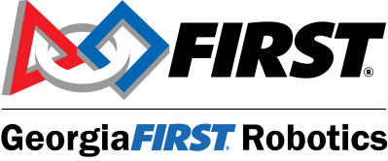

www.gafirst.org

Follow us on Twitter/X at: @georgiafirst
Follow us on Instagram at: @georgia_first

Connect with us on Facebook at: GeorgiaFIRST Robotics

Welcome to the 2024 Peachtree District Championship Event at Mercer University in Macon, GA. As we celebrate year nine of district play in Georgia and year two of district play in South Carolina, we would like to congratulation your team for advancing alongside the best robotics teams in the district.

We look forward to seeing how you solved this year’s challenge, Crescendo! This week marks the culmination of months of hard work, creative problem solving and incredible teamwork. Here, on the arena floor, you will test your design, strategy and fabrication skills. You have learned what it means to be part of a team and you have contributed to its success. In the spirit of Gracious Professionalism®, your opponents will become your friends and colleagues – for years to come.

To all our volunteers, mentors, teachers, and parents: thank you for your year-round support to create this outstanding opportunity for our students. Your investment of time and energy has been significant, and you have served as terrific role models. You have positively impacted this next generation of innovators, educators, engineers and leaders and you should be proud of your accomplishments!

To all our sponsors and partners: you play a critical role in the success of our program with your commitment of funding, volunteers, internships, and leadership. You know the importance of a workforce that is technically astute, innovative, energized and recognize that FIRST participants are the future workforce that keeps our country competitive in the global economy. This Championship event and our year-round STEM related activities have been made possible thanks to your support!

We invite everyone to join us to cheer for these students as they put into play lessons and skills learned over the past several months. Watch them compete on the arena floor and visit them in the pits. Talk to them and congratulate them! They are all winners! They are our future!

On behalf of the leadership of GeorgiaFIRST Robotics and FIRST in South Carolina, we wish all participating team members great success, volunteers amazing fun and spectators super charged excitement! Best of luck to everyone!

Brian Cooksey Connie Haynes
President, GeorgiaFIRST Board of Directors CEO
Shaw Industries GeorgiaFIRST Robotics

Jan Spurlin Chris Cortez
Chair, GeorgiaFIRST Leadership Committee FRC Program Delivery Partner
Service Now FIRST South Carolina

PCH Championship Event Schedule*

(Day 0) 4-4-24 Thursday
8:00am Pits Open, Team Load-In, Registration, Pit Set-Up, Inspections
9:00am-10:00am Field Open for Calibration and Measurement
10:00-12:00pm Girls FIRST Event (Pre-Registration Required)
11:00-12:00pm Road to Championship (Mentor & Coaches)
12:00pm - 1:00pm Lunch
12:30pm - 1:00pm Safety Captains Meeting
1:00pm-4:00pm Practice Rounds on Field
4:00pm-5:00pm Break on Field
4:00pm-4:30pm Drivers Meeting on Field
5:00pm-7:00pm Qualification Matches
7:30pm Pits Close
7:00pm – 9:00pm Team Social at Penfield Hall and Cruz Plaza

(Day 1) 4-5-24 Friday
8:00am Pits Open
8:30am - 9:00am Opening Ceremony
9:00am - 12:00pm Qualification Matches
12:00pm - 1:00pm Lunch
12:45pm Senior Photo on Field
1:00pm - 6:00pm* Qualification Matches
6:00pm Awards Ceremony on Field
7:00pm* Pits Close

(Day 2) 4-6-24 Saturday
8:00am Pits Open
8:30am - 9:00am Opening Ceremonies
9:00am - 12:00pm Qualification Matches
*Scheduled times are subject to change based upon run schedule, field issues, or other factors.
12:00pm - 1:00pm Alliance Selections
1:00pm - 2:00pm Lunch
2:00pm - 6:00pm Playoff Matches & Awards Ceremony
2:30pm* Practice Field Closes
6:00pm* Pits Close

Registered Teams

281 The GreenVillains Greenville SC
342 Burning Magnetos North Charleston SC
343 Metal-In-Motion Seneca SC
1102 M'Aiken Magic Aiken SC
1261 Robo Lions Suwanee GA
1287 Aluminum Assault Myrtle Beach SC
1414 IHOT Atlanta GA
1648 G3 Robotics Atlanta GA
1683 Techno Titans Johns Creek GA
1746 OTTO Cumming GA
1771 North Gwinnett Robotics Suwanee GA
2415 WiredCats Atlanta GA
2815 Blue Devil Mechanics Columbia SC
2974 Walton Robotics Marietta GA
3329 Wildbots Kingsland GA
3489 Category 5 Summerville SC
3490 Viper Drive Summerville SC
3635 Flying Legion Warner Robins GA
3815 NF Raiders Cumming GA
4026 Decatur Robotics Decatur GA
4112 EagleBots Cumming GA
4188 Columbus Space Program Columbus GA
4451 ROBOTZ Garage Fountain Inn SC
4509 Mechanical Bulls Sugar Hill GA
4533 Phoenix Mount Pleasant SC
4701 Warriors (Team W.I.R.E.) Savannah GA
5109 Gladiator Robotics Johns Creek GA
5130 Undercogs LIttle River SC
5293 Metal Crusaders Duluth GA
5900 The Fighting Mongooses Dalton GA
6340 The Marist Manatees Atlanta GA
6366 RAM Rodz Robotics Simpsonville SC
6829 Ignite Robotics Suwanee GA
6919 The Commodores Albany GA
6925 W.A.Robotics College Park GA
7451 Avenger Robotics Cumming GA
7538 Metal Mountain Lawrenceville GA
8080 Sequoyah Robotics Canton GA
8575 The Due Westerners Due West SC
8577 GCA Champions Atlanta GA
8736 The Mechanisms Marietta GA
8849 Storm Robotics Alpharetta GA
8865 Dacula Droids Dacula GA
9260 Built4Bibb Robotics Macon GA
9477 Lambert Robotics Suwanee GA
9480 Gear Bears Flowery Branch GA
9500 G28 Robotics Atlanta GA
9522 Archimedes Flowery Branch GA
9571 PVHS Coders Greenville SC
7104 Bot Brothers Savannah GA

The Ultimate Sport for the Mind!
EVENT SPONSORS

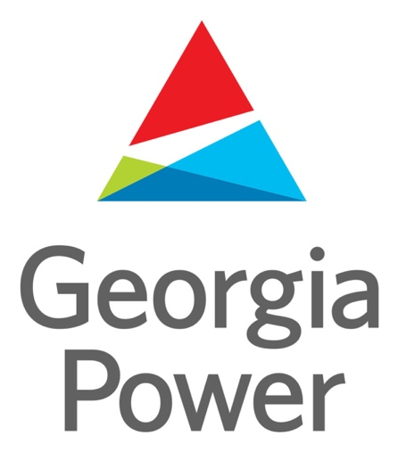

THANK YOU FOR MAKING THIS EVENT POSSIBLE!

2024 Sponsors

Aflac Atlanta Gas Light Automation Direct Bishop Clean Care
Carrier City of Albany Cobb County School System Coca-Cola Corporation Comcast Community Foundation NWGA Dalton Convention & Visitors Bureau Dalton State College Georgia Assoc. of Manufacturers Georgia Department of Education Georgia Northwestern Tech College Georgia Power Georgia Tech Georgia United Credit Union
Google Gwinnett County School District Johnson Research & Development Kennesaw State University Kimberly-Clark Corporation Lockheed Martin Mercer University Milner Muscogee County School System NCR Foundation Neos North Georgia EMC NWGA College & Career Academy Novelis PPG Foundation Procter and Gamble Shaw Industries Southwire UPS Verizon 4C Academy, Albany

THANK YOU FOR YOUR SUPPORT OF GEORGIAFIRST AND THE PEACHTREE DISTRICT!

Event Judges

Dr. Bryan Haynes, State Lead Judge, Kimberly Clark
Frank Borowiec
Tom Cleveland
Trish Hallstone
Doug Huggins
Dr. Lonnie Johnson
Jose Luna
Jessica Namaste
Makenzey McDaniel
Sue Miller
Ashi Patel
Tara Persinger
Jeremy Roberts
Kasie Scott
Kenneth Wheeler
Catherine Zende

GeorgiaFIRST relies on dedicated volunteers and appreciates the contribution of time from everyone who participates. From the expertise of veterans who return year after year, to the enthusiasm of rookies, volunteers are the critical component that makes our events successful.

YOU inspire. YOU motivate. YOU influence. YOU transform lives.
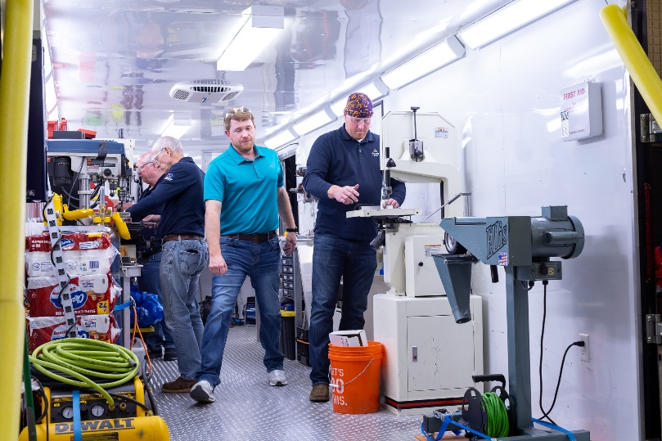
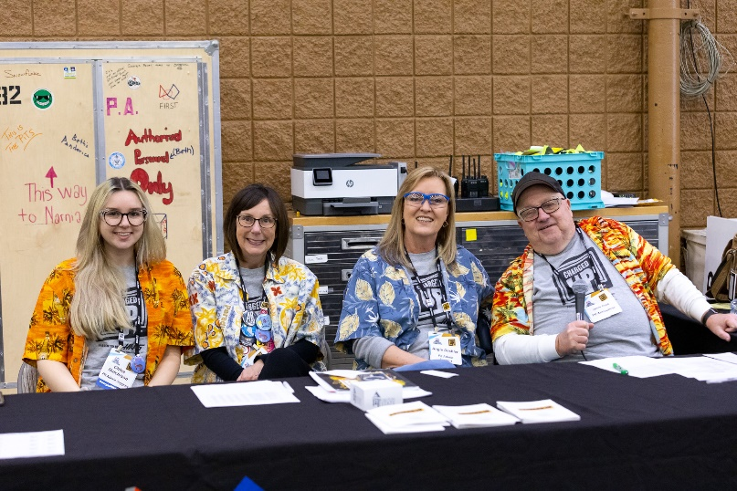
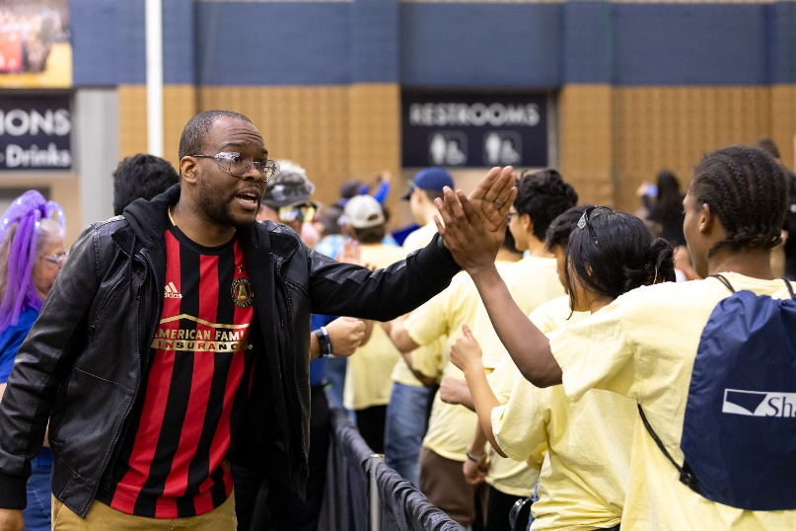
For this we say THANK Y OU!
2024 Game Description

In CRESCENDO presented by Haas, two competing alliances are invited to score notes (game pieces), amplify their speaker, harmonize onstage, and take the spotlight before time runs out. Alliances bring additional rewards for meeting specific scoring thresholds and for cooperating with their opponents.

SCORING PERIODS

:15 Autonomous Period: Robots follow pre-programmed instructions and run autonomously (without guidance from their human drivers). During Autonomous, Alliances score points by:
- Leaving their starting zone,
- Retrieving and scoring notes (game pieces) in their speaker or amp,

2:15 Driver-Controlled Period: Drivers take control of the robots and Alliances score points by:
- Collect notes (game pieces) from human players at their source and score them in their amp or speaker,
- Each time an Alliance gets 2 notes in their amp, the human player can amplify their speaker for 10 seconds which increases the point value for any notes scored during the 10 second period.
- Coopertition Period – Human players may choose to repurpose a note scored in their amp in cooperation with their opponent. If each Alliance repurposes a note by hitting their Coopertition button in the first 45 seconds of this period, all teams in the match receive a Coopertition point.
- As time runs out, robots race to get onstage and deliver notes to their traps. Chains exist on the stage that robots try to hang on (robots must be off the floor). A human player can also toss a note onto the pipe (microphone) sticking above the stage for additional points.

The alliance with the highest score at the end of the match wins!
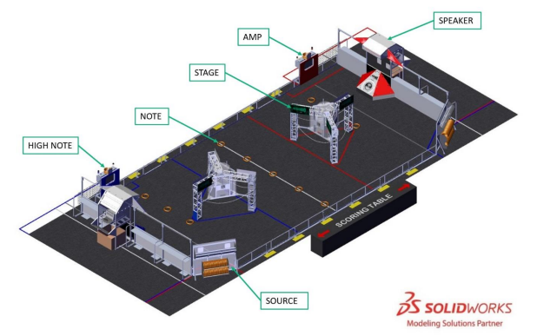
District Ranking Explanation

In the District Model of competition, teams are ranked throughout the season based on the points they earn at their first 2 home District events they attend, as well as at their District Championship. Below is a breakdown of how points are awarded to teams from the FIRST Robotics Competition (FRC) Administrative Manual.

Point Category | Points
Qualifying Rounds
Qualification Round Performance | 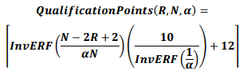  (For typically-sized district events, this will result in a minimum of 4 points being awarded for qualification round performance. For events of all sizes, a maximum of 22 points will be awarded)
Alliance Selection Results After Alliance Selection is Complete
Alliance Captains  Draft Order Acceptance | Equal to 17 minus the Alliance Captain Number [e.g. 14 points for Alliance #3 Captain]  Equal to 17 minus the Draft Order Acceptance Number [e.g. 12 points for the Team that is 5th to accept an offer of Alliance]
Playoff Advancement
Teams on Alliances Advancing | Points awarded based on team participation in individual playoff rounds, and whether or not the alliance advances.
Awards
Judged Team Awards | 10 Points for Impact Award  8 Points each for Engineering Inspiration and Rookie All Star Awards  5 Points each for all other judged Team awards
Team Age
Team Age | 10 Points for Rookie Teams  5 Points for second-year Teams

Points earned at District Championships are multiplied by 3 and then added to points earned at District events, to determine the final season point total for the team. If there is a tie in the season point total between teams, a tie-breaker criteria is applied.

Event Awards
At each district event, volunteers serve as Judges. Judges interview and observe teams in action and determine awards that are distributed during the closing ceremonies of each competition. The following is a list of FIRST® Robotics Competition awards. Every award may not be presented at every FIRST® Robotics Competition event.

Autonomous Award -- Celebrates the team that has demonstrated consistent, reliable, high-performance robot operation during autonomously managed actions.

Creativity Award sponsored by Rockwell Automation -- Celebrates creativity in design, use of component, or strategy of play.

Engineering Inspiration Award -- Celebrates outstanding success in advancing respect and appreciation for engineering within a team’s school and community.

Excellence in Engineering Award -- Celebrates an elegant and advantageous machine feature.

Finalist -- Celebrates the Alliance that makes it to the final match of the competition.

FIRST Dean’s List Award -- Celebrates outstanding student leaders whose passion for and effectiveness at attaining FIRST ideals is exemplary.

FIRST Impact Award -- The most prestigious award at FIRST, it honors the team that best represents a model for other teams to emulate and best embodies the mission of FIRST

Gracious Professionalism® Award -- Celebrates outstanding demonstration of FIRST Core Values such as continuous Gracious Professionalism® working together both on and off the playing field.

Imagery Award in honor of Jack Kamen -- This award celebrates attractiveness in engineering and outstanding visual aesthetic integration of machine and team appearance.

Industrial Design Award sponsored by General Motors -- Celebrates form and function in an efficiently designed machine that effectively addresses the game challenge.

Innovation in Control Award -- Celebrates an innovative control system or application of control components – electrical, mechanical, or software – to provide unique machine functions.

Judges’ Award -- During the course of the competition, the judging panel may decide a team’s unique efforts, performance, or dynamics merit recognition.

Quality Award -- Celebrates machine robustness in concept and fabrication.

Rookie All-Star Award -- Celebrates the rookie team exemplifying a young but strong partnership effort, as well as implementing the mission of FIRST to inspire students to learn more about science and technology. NOTE: This award may not be earned at each qualifier event.

Rookie Inspiration Award -- Celebrates a rookie team’s outstanding success in advancing respect and appreciation for engineering and engineers, both within their school, as well as in their community.

Safety Animation Award sponsored by UL Solutions – Challenges teams to encourage safe practices by tapping into their creativity and influencing emotions and actions.

Team Spirit Award -- Celebrates extraordinary enthusiasm and spirit through exceptional partnership and teamwork furthering the objectives of FIRST.

Team Sustainability Award sponsored by Dow -- Celebrates and recognizes a team which has developed a sustainable program in order to define, manage, and achieve the team’s ongoing objectives.

Winner -- Celebrates the Alliance that wins the competition.

Woodie Flowers Award -- Recognizes an individual mentor who has done an outstanding job of motivation through communication while also challenging the students to be clear and succinct in their communications. Students on each team decide whom to nominate.
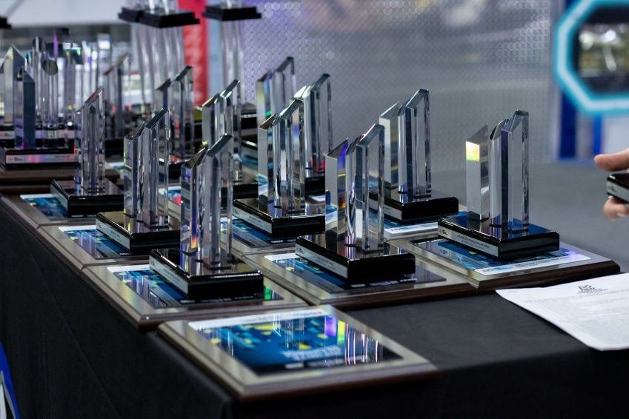
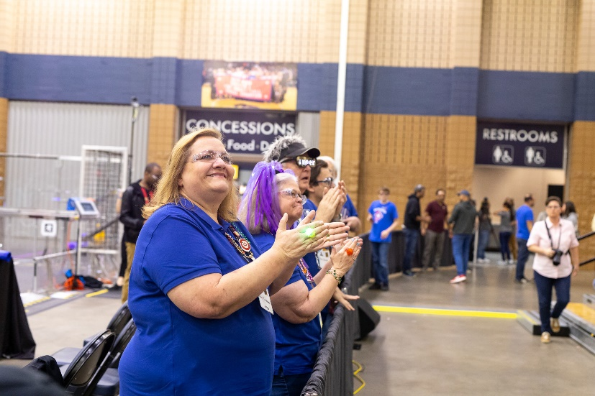
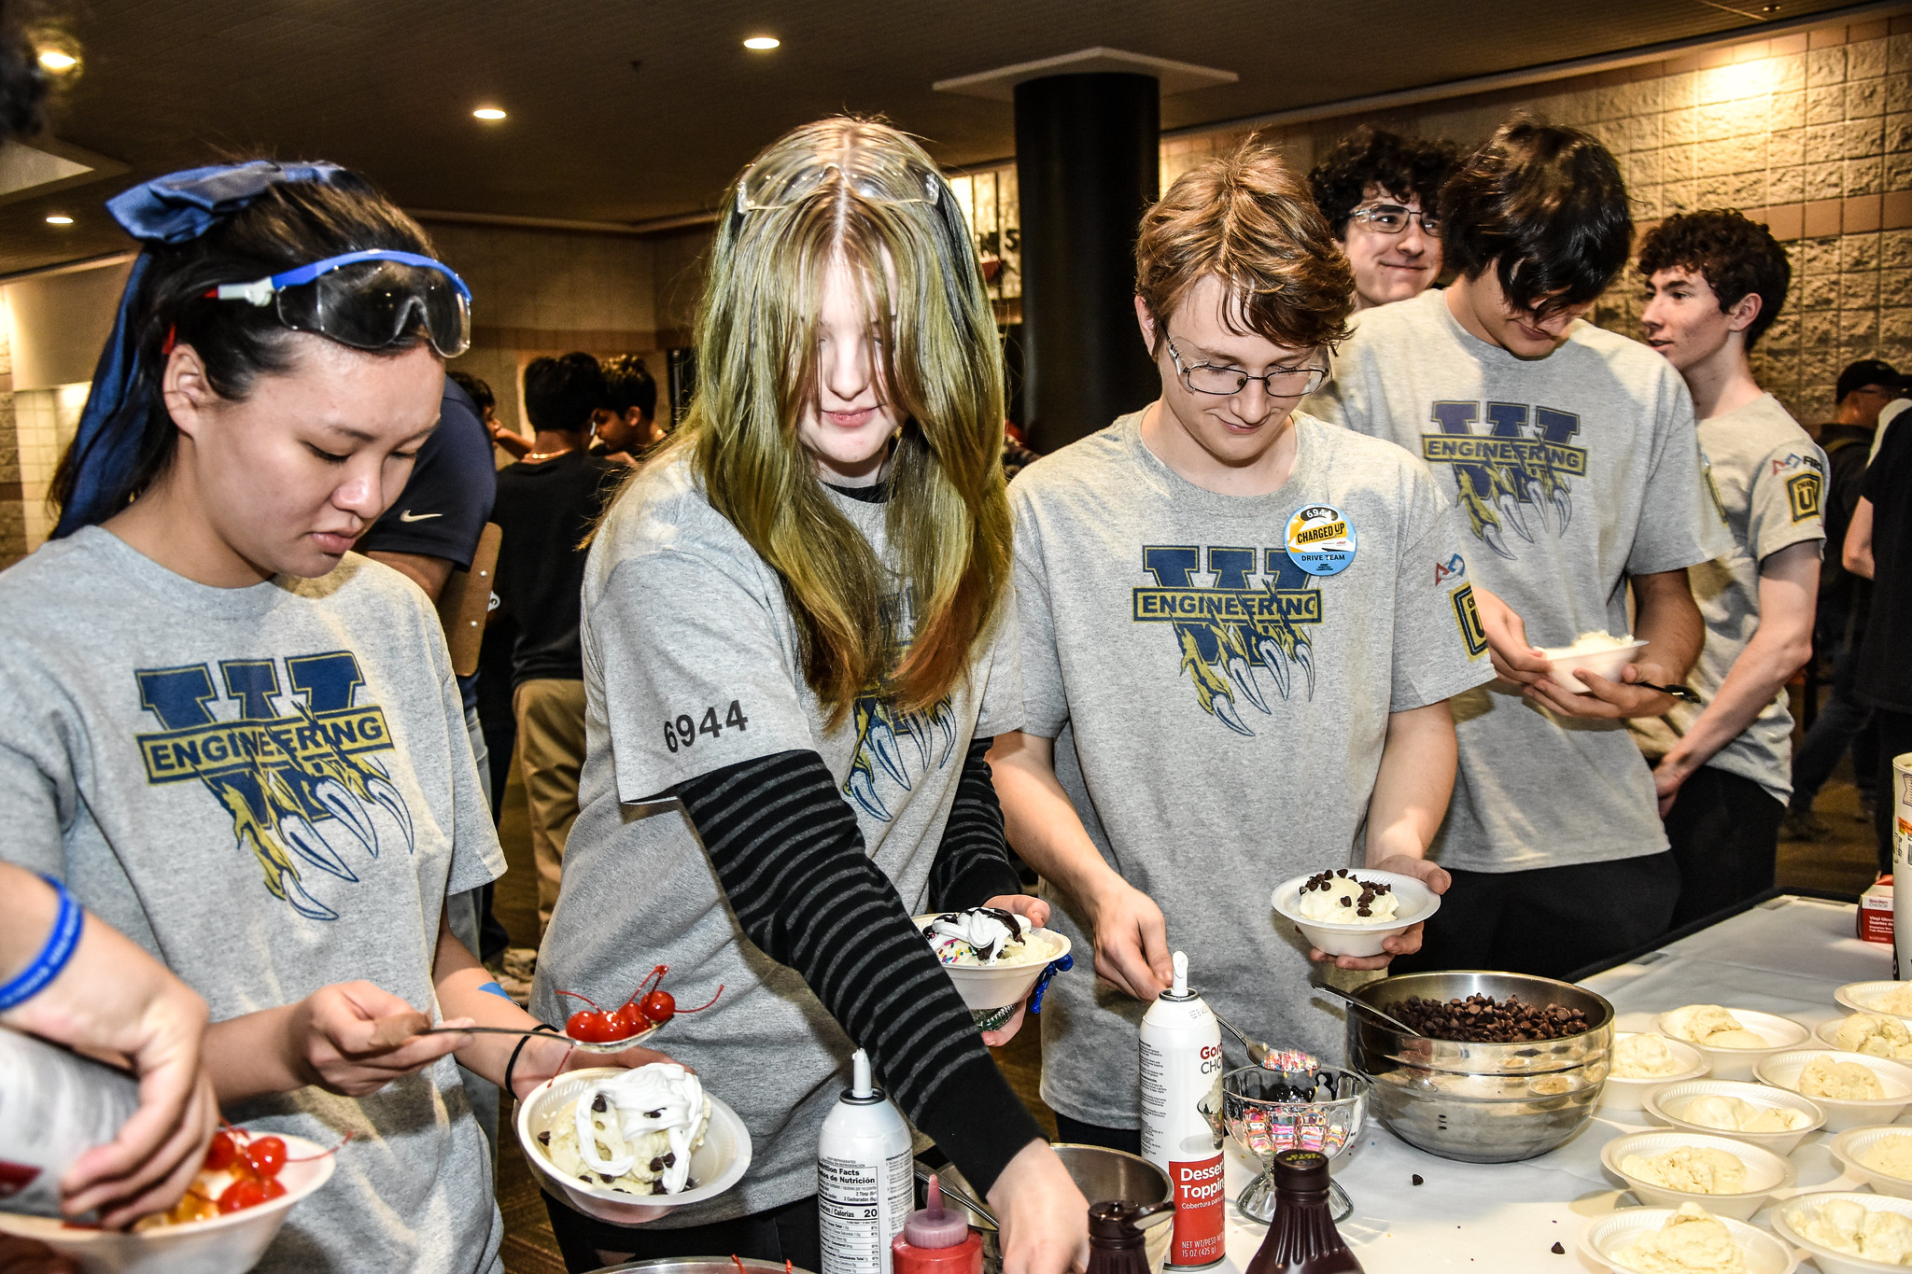
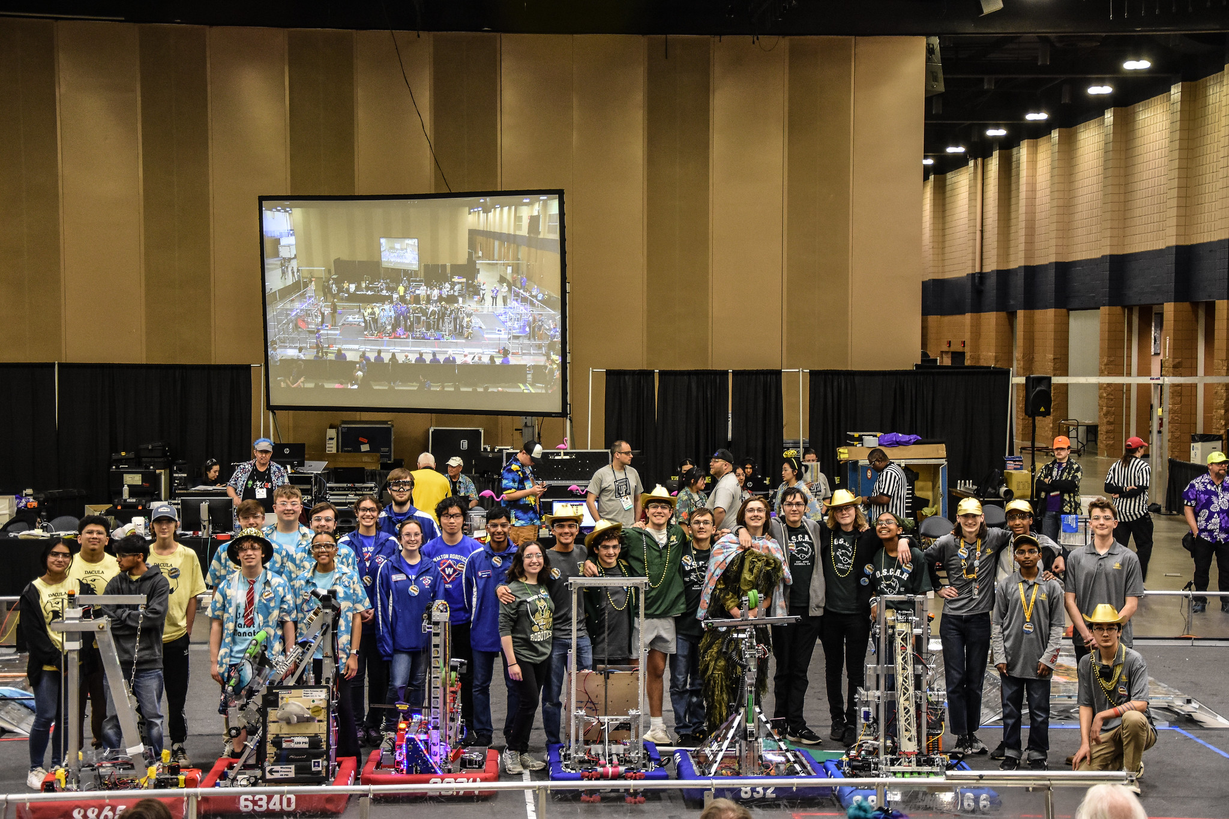
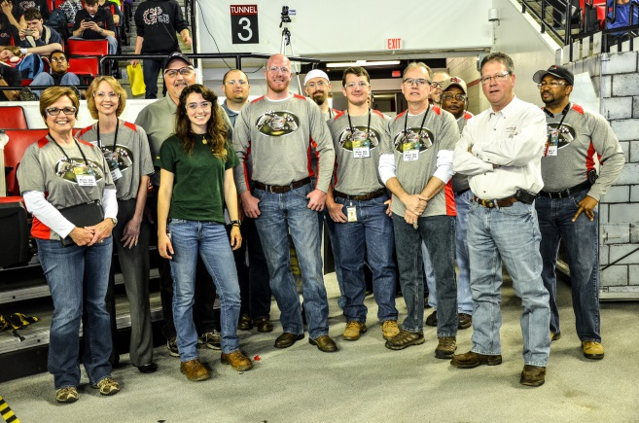
Thank you to all our generous sponsors, our faithful and energetic volunteers and the dedicated mentors who give countless hours to make FIRST possible for their students. Each FRC event relies on 100+ volunteers to plan and execute. As an all-volunteer organization, we pride ourselves on quality, safety and an overall experience of fun. Thank you to all those who work tirelessly behind the scenes to make FIRST happen.

The best of luck to all FRC teams this season from your
GeorgiaFIRST Leadership Council!

Parker Bass Adam Churney
Beth Culp Tiffany Dean Charles D’Englere Lisa Hatch Bryan Haynes Connie Haynes Kellen Hill Jackie Holland Scott Lee Ross Lindsay Roy McConnell Monish Patil
Jeff Rees Flint Shephard Jan Spurlin Ray Spurlin Greg Welsch Kathy Wood

Family and friends can watch the event live here: www.gafirst.org

How can you support GeorgiaFIRST?

Form a Team
- Learn from engineering pros.
- Apply math and science concepts to design and build robots.
- Gain hands-on experience solving real-world problems.
- Learn about exciting science and technology careers.
- Make new friends.

Contact: Lisa Hatch lhatch@gafirst.org
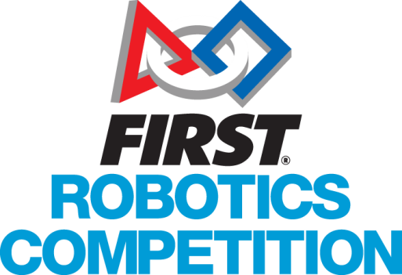

Be a Volunteer
- Become a Mentor or Coach.
- Organize an event or program.
- Assist at a competition.
- Make a difference in young lives.

Contact: Tiffany Dean tdean@gafirst.org

Become a Team or Event Sponsor
- Provide financial support, equipment, parts, facilities, internships, or other services.
- Offer scholarships.
- Encourage employees to mentor or volunteer.
- Host an event.
- Build community goodwill.
- Inspire employees.
- Help build a technical workforce.

Contact: Connie Haynes (770) 366-5612 chaynes@gafirst.org

Take the next step and contact chaynes@gafirst.org to get involved!
www.gafirst.org www.firstinspires.org

